## iBanker

Documentation

Date : 05-Nov -23



**Third Semester (E-Project)**

**iBanker**

# Acknowledgement

*Thanks to Almighty Allah, The most Beneficial and The most merciful, Who gave us mind to think and Heart to feel creativity & creation depends on thinking*

*With His Grace & Mercy for giving us strength and ability to make us complete this Project. I would like to express our gratitude and appreciation to all those who gave us the possibility to complete this project, a special thanks to my teacher.*

*Sir Asad Ali, Who’s help, stimulating suggestions & encouragement, helped us to coordinate in our project. We would also like to express our deepest gratitude to our beloved parents whose wellwishes enabled us to transform our dream & thought into a reality.*

*We hereby presenting project in titled* “**iBanker**” *in your hands.*

*We have tried our best to take all relevant and important topics in consideration so that this project May become more effective & a better outlook to come. We earnestly hope that this project will provide all the necessary information required for the user to fulfill their requirement. However, suggestion for improvement of the project will be thankfully acknowledge.*

## Index

1. Problem Definition
2. Proposed Solution
3. Frontend
4. Backend

### Problem Definition

*The iBanker project aims to address the challenge of outdated and inefficient banking systems by developing a comprehensive digital banking solution. The existing banking infrastructure often lacks user-friendly interfaces, real-time transaction processing, and personalized financial management tools. iBanker seeks to revolutionize banking by creating a secure, intuitive, and technologically advanced platform that enhances the overall banking experience for users while ensuring robust security measures..*



### Proposed Solution

*iBanker proposes a revolutionary digital banking solution, featuring an intuitive user interface for seamless navigation and real-time transaction processing. Personalized financial management tools cater to individual preferences, enhancing budgeting, expense tracking, and investment insights. Advanced security measures, including multi-factor authentication and encryption, prioritize the protection of user data. With scalability and adaptability at its core, iBanker aims to redefine traditional banking, providing users with an efficient, secure, and comprehensive digital banking experience.*



### Required Features

* *Registration for customer as well as iBanker Team.*
* *Panel for iBanker Team showcasing their details*
* *Panel for User showcasing their details*
* *Login through normal registration form for customer is mandatory and for a iBanker registration form is required. Basically user/password required.*

### User Types

• *Admin: To manage information that we will be seen in homepage and manage all of things in our website. Manage schedules and appointment for Cheque Book .*



### Module Details

* *Customer / iBanker Team registration*
* *Panel for iBanker Team*
* *Panel for User*
* *View User profile / Book Appointment*
* *Login through normal registration form for customer is mandatory and for a lawyer registration form is required. Basically user/password required*
* *Admin Pages*

### Our Team

|  |  |  |
| --- | --- | --- |
|  |  |  |
| *StudentId* | *Name* | *Work* |



|  |  |  |
| --- | --- | --- |
| Student1348826 | Muhammad Hammad | Backend |
| Student1352080 | Arbaz Haider | Database |
| Student1349237 | Muhammad Zain ul Abideen | Web Designer |
| Student1346898 | Irfah Mustafa (G.L) | Admin Panel |

**FRONT-END SECTION**

**Code Snippets And Screenshots Of Our Website’s UI Are Found In This Section**

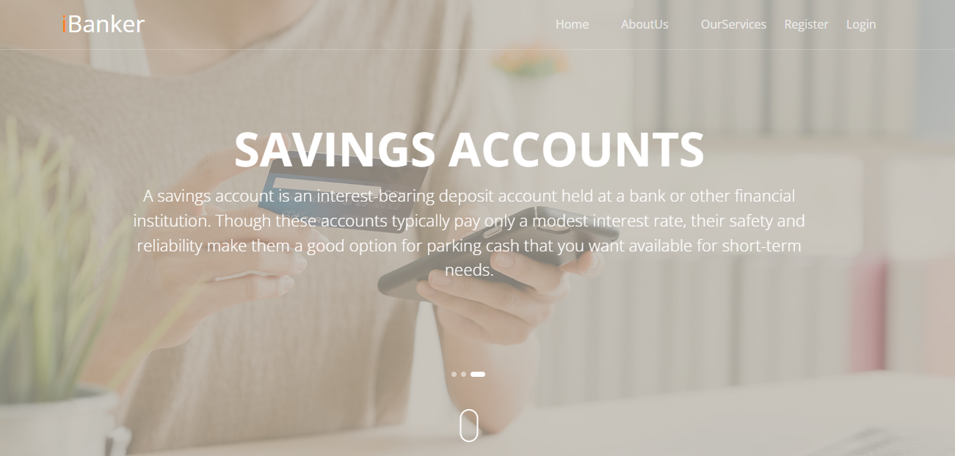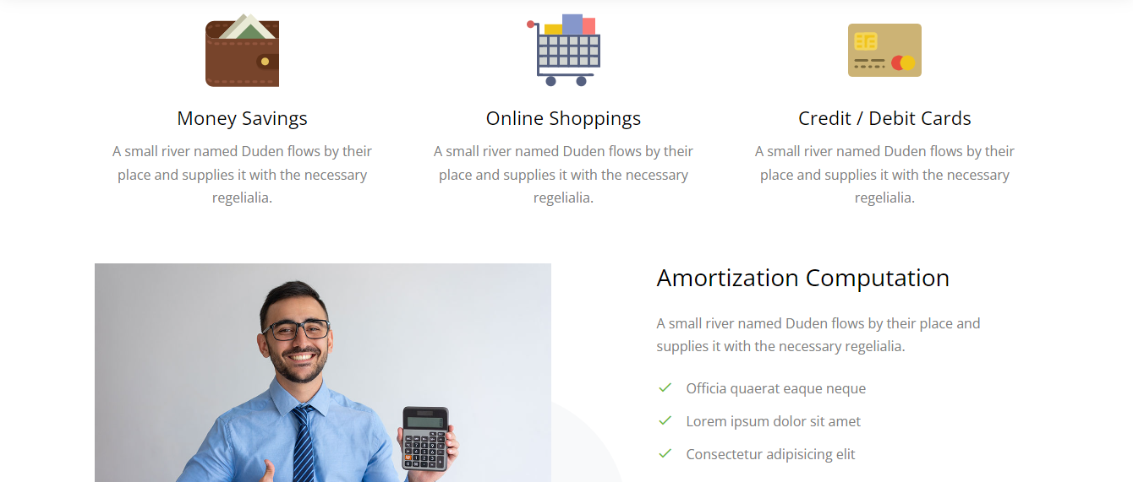

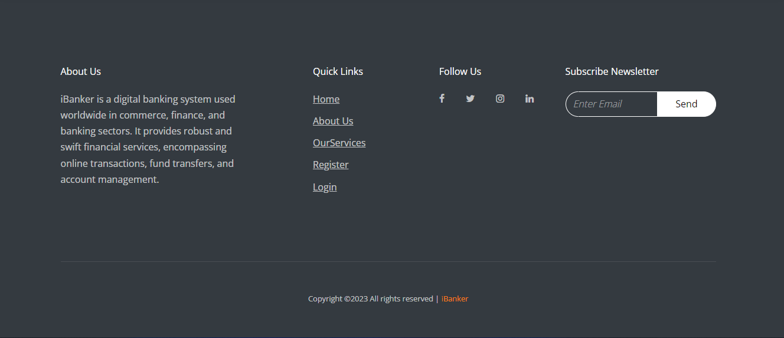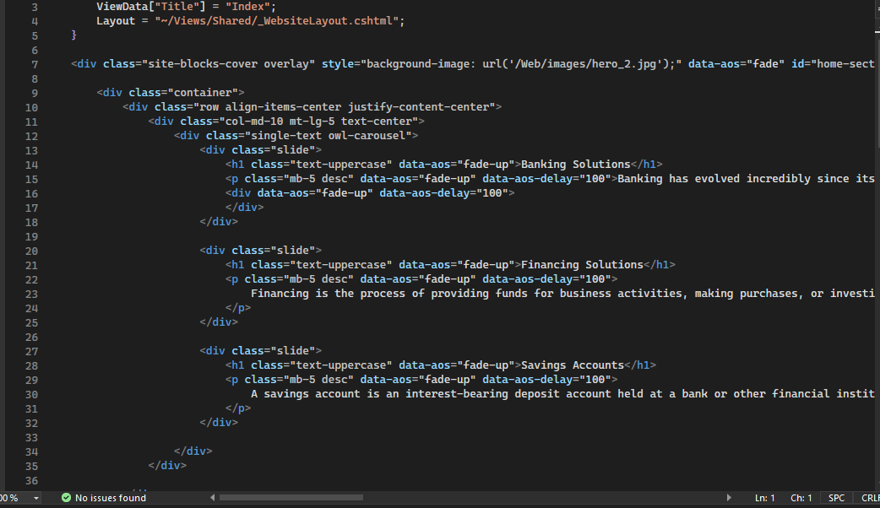

## Our AboutUs Page

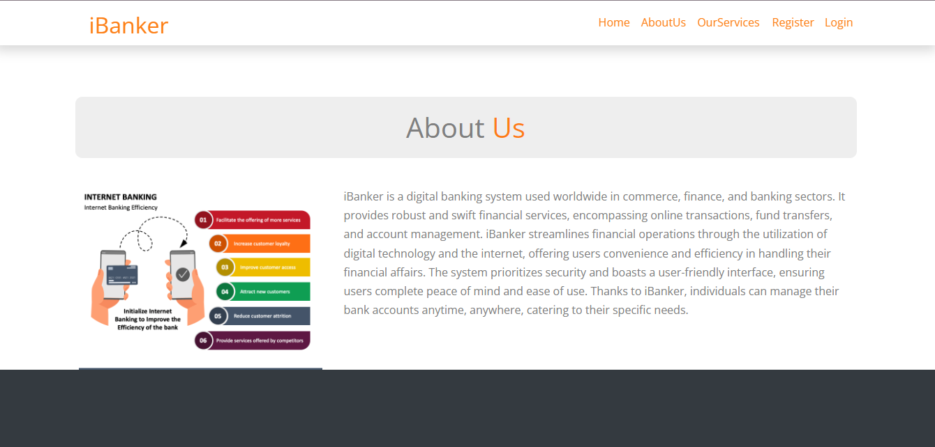

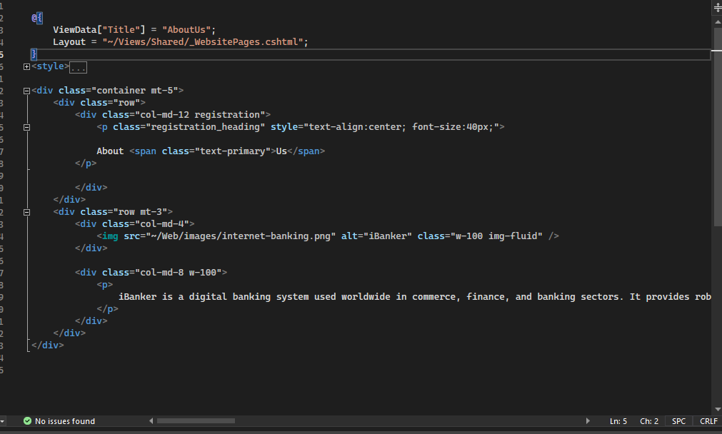

## Our Services Page

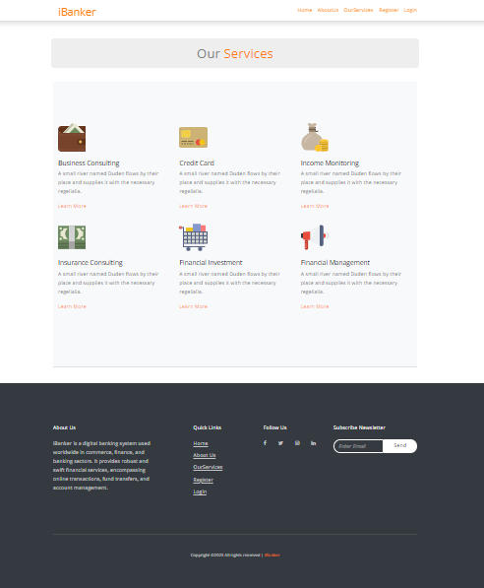

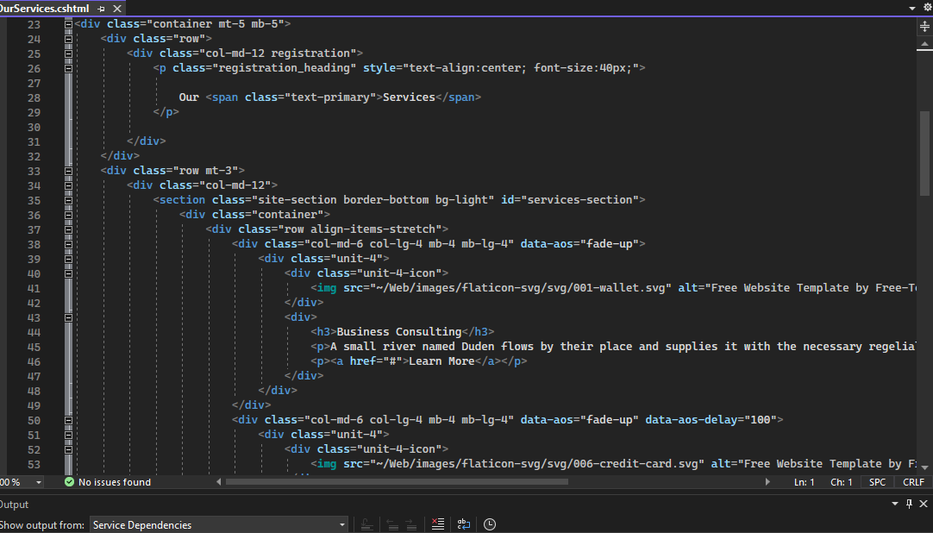

## Our Register Page

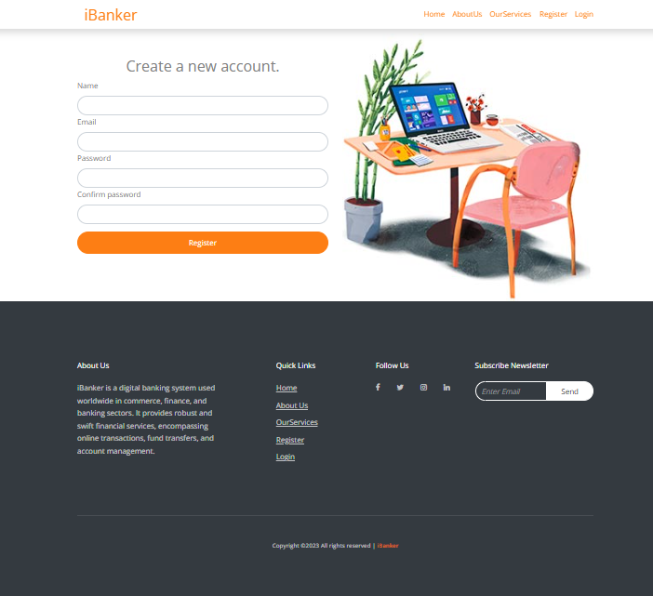

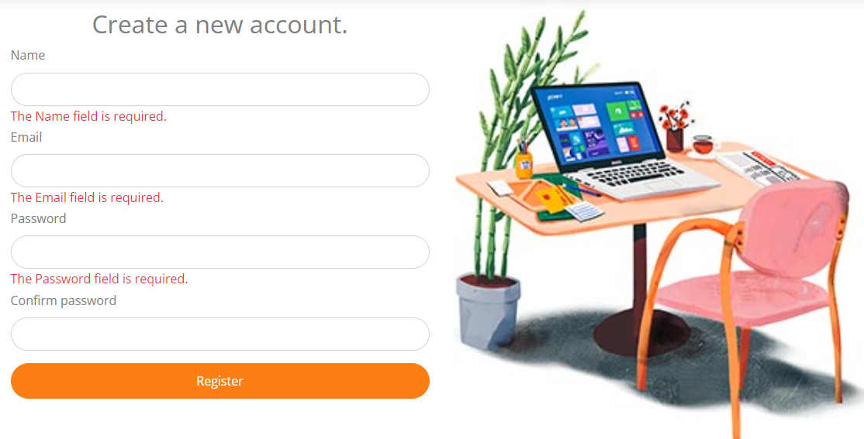

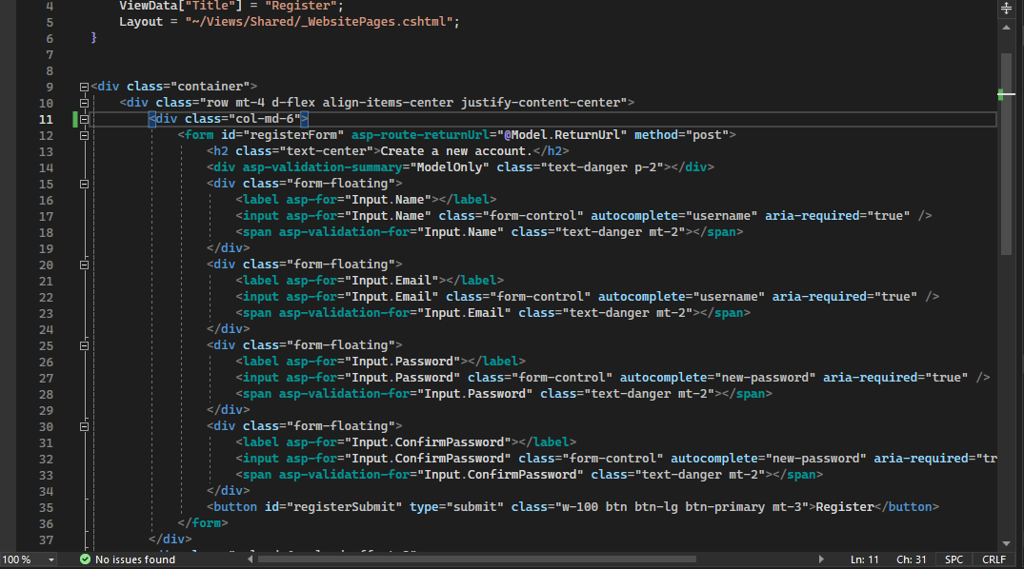

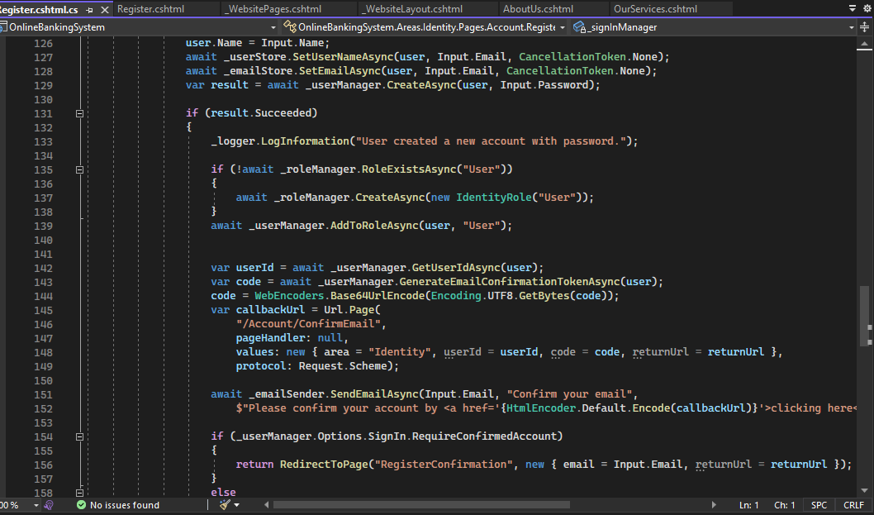

## Our SignIn Page

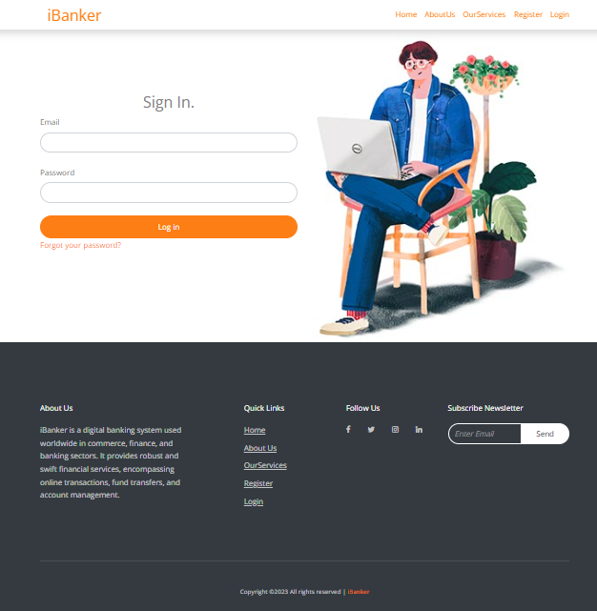

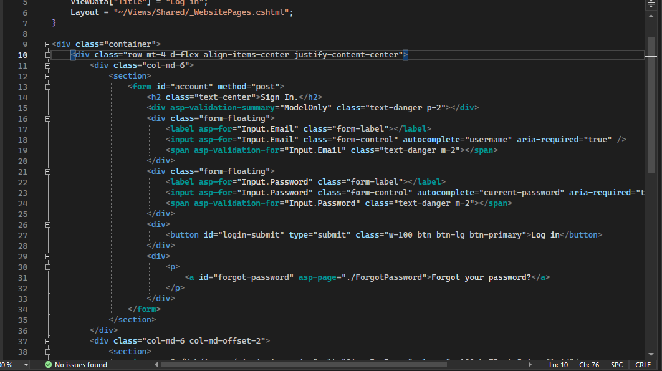

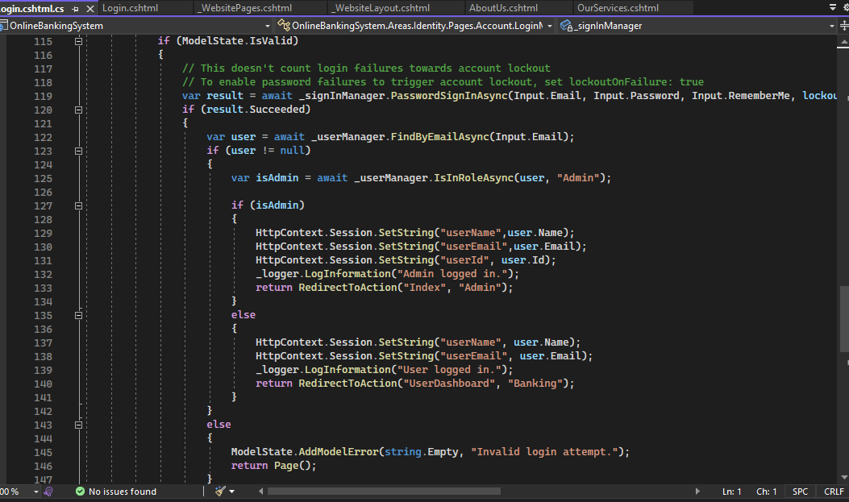



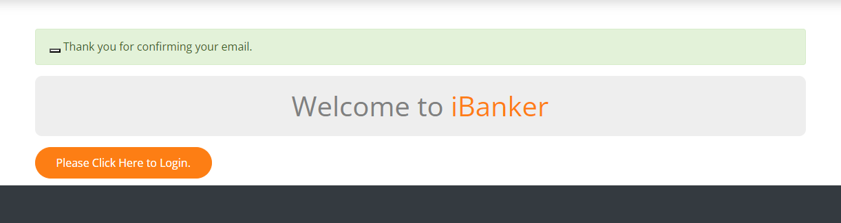

## Our User Panel

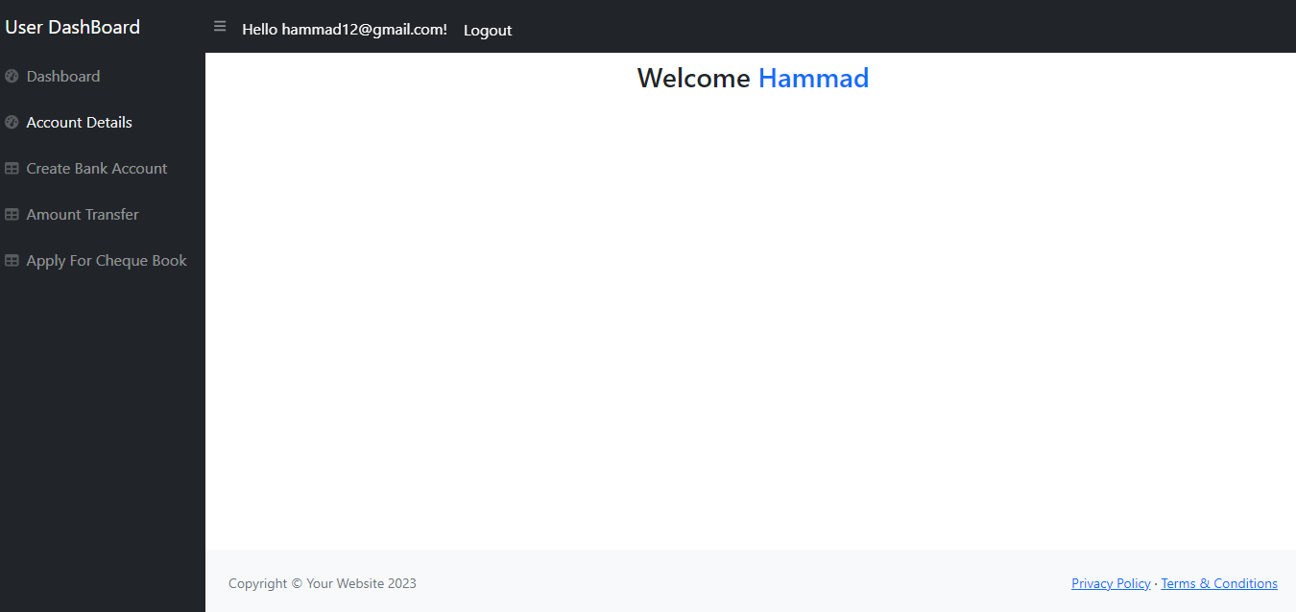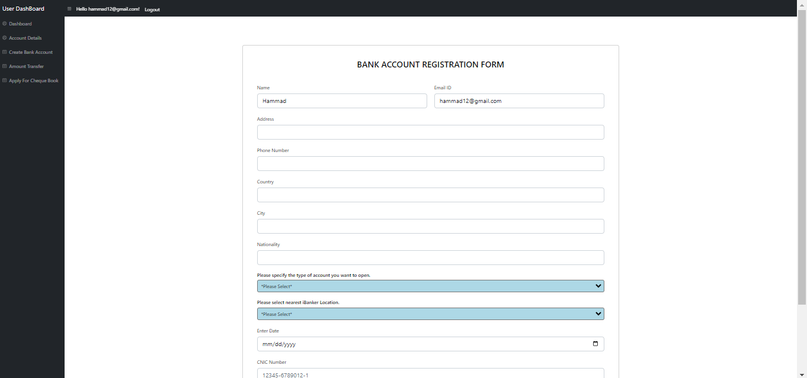

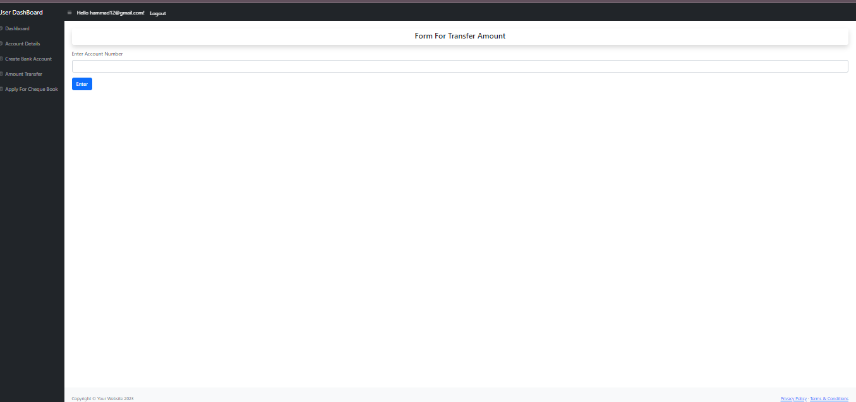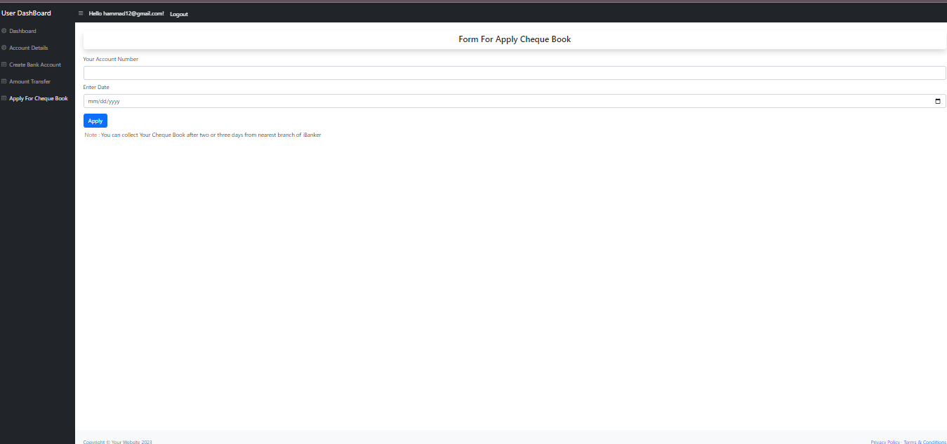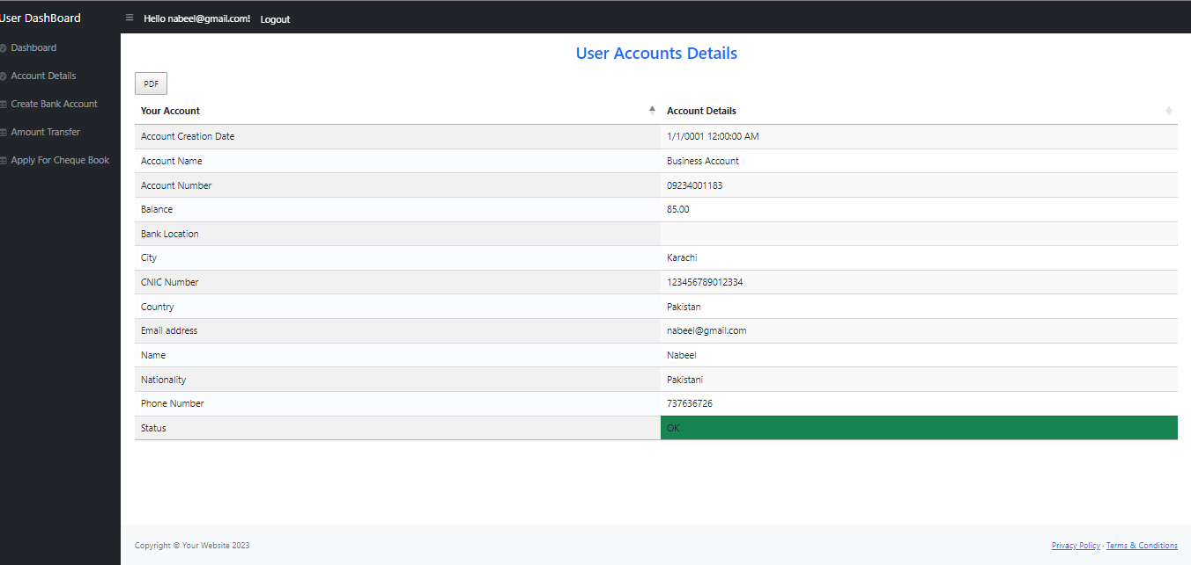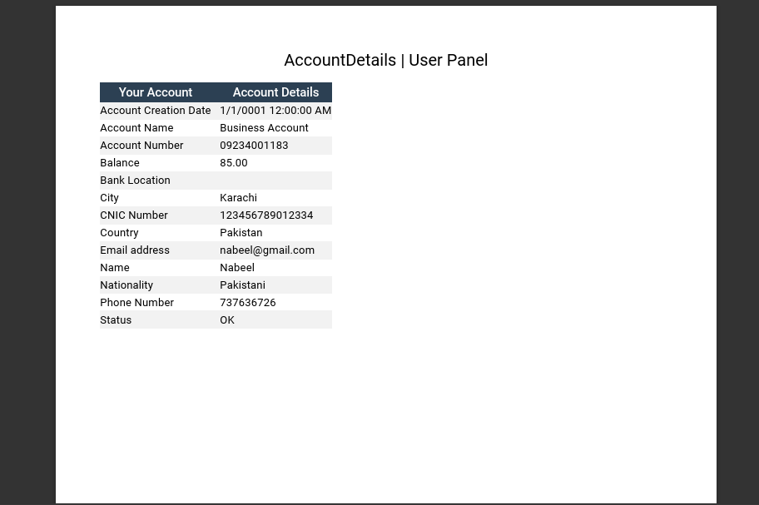

## Our Admin Panel

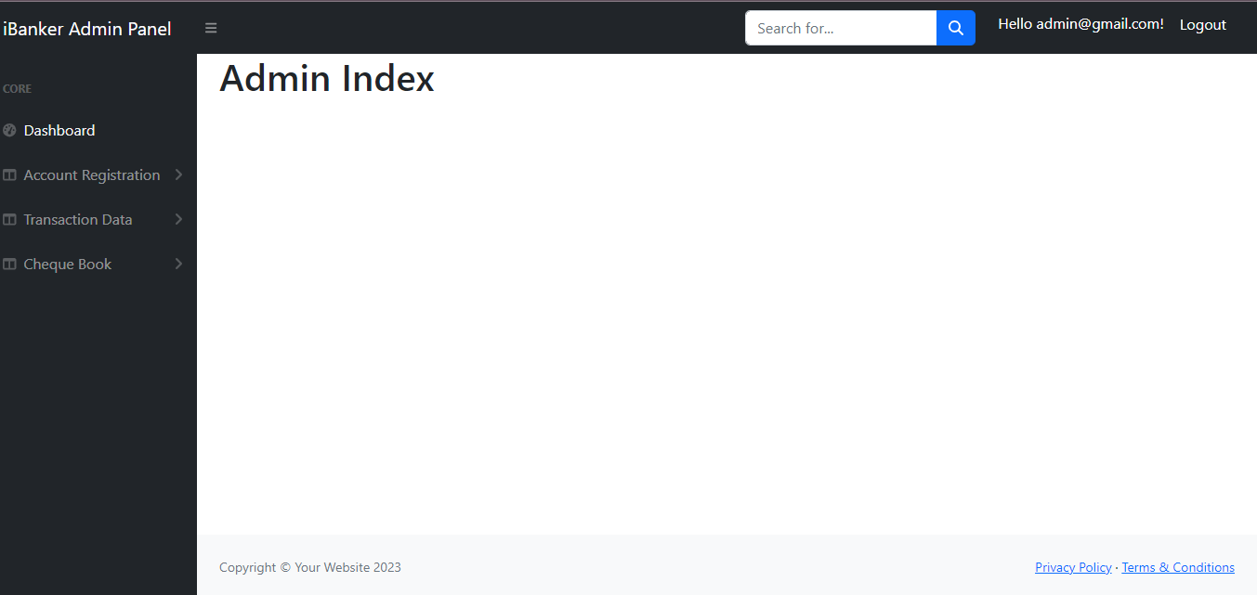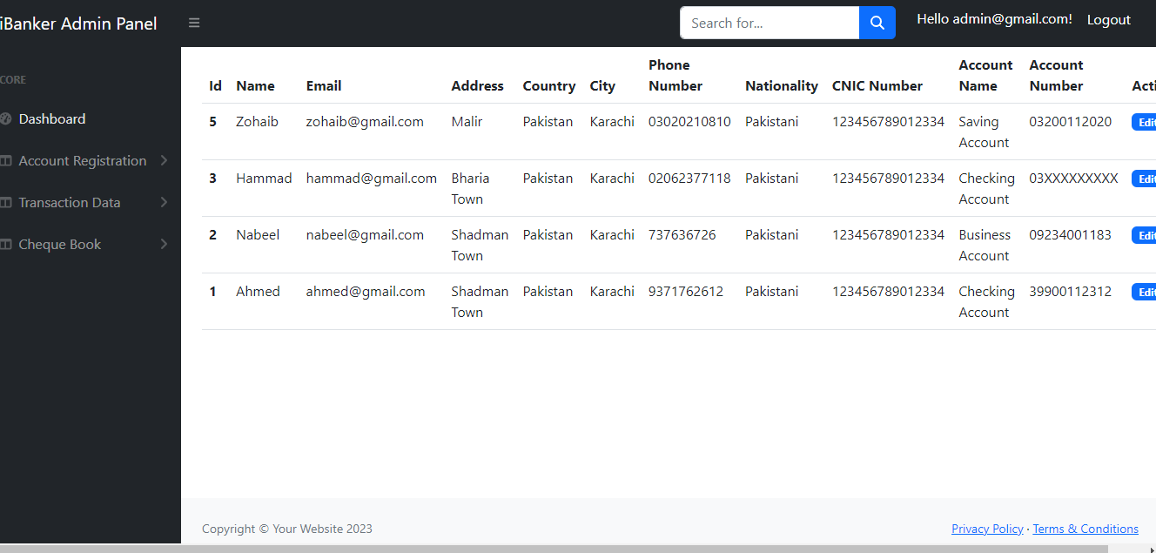

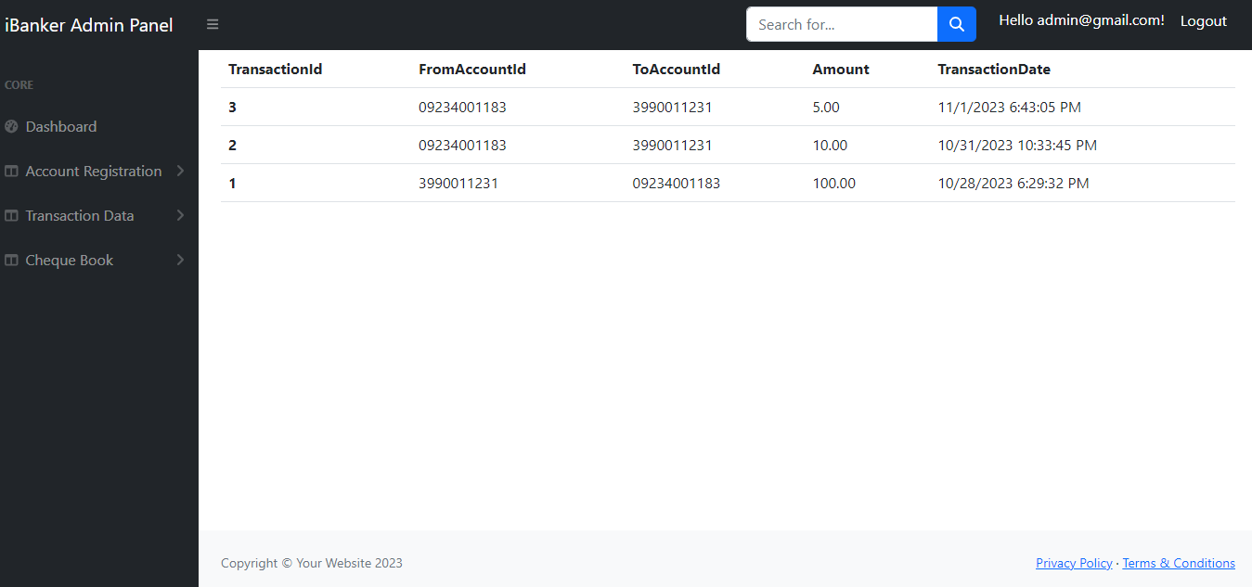

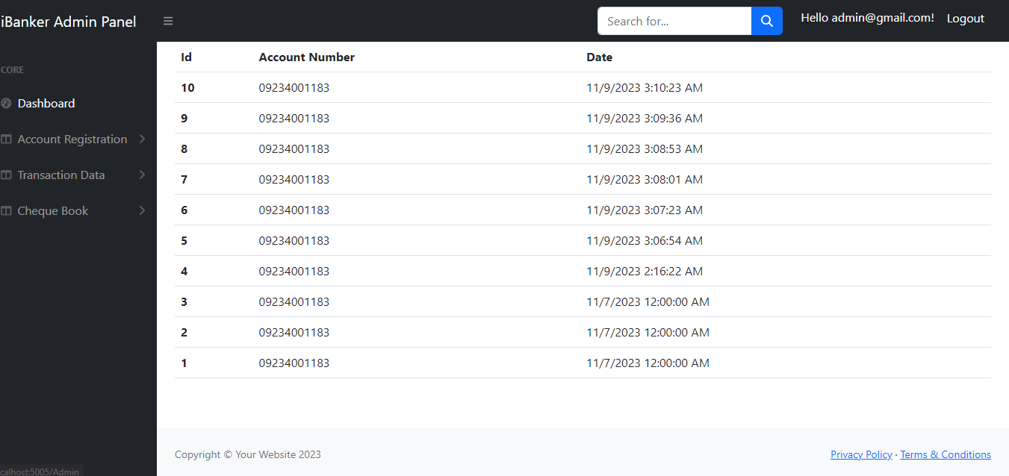

## BackEnd Portion

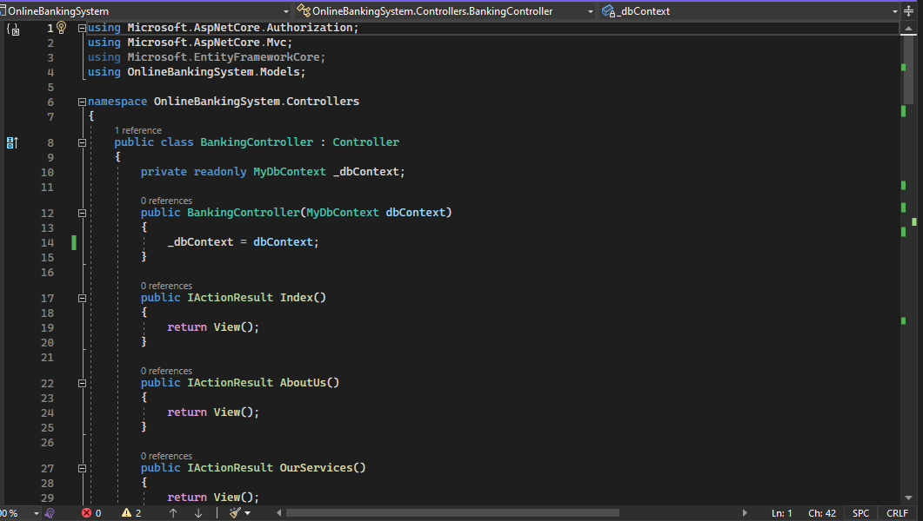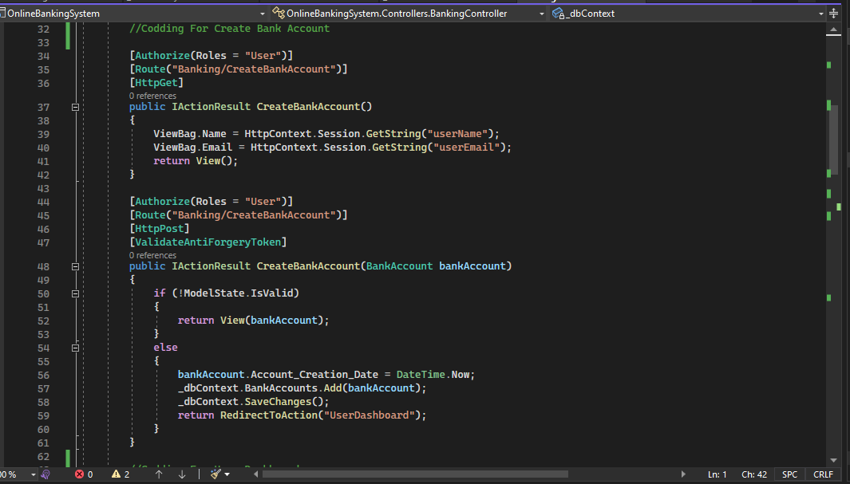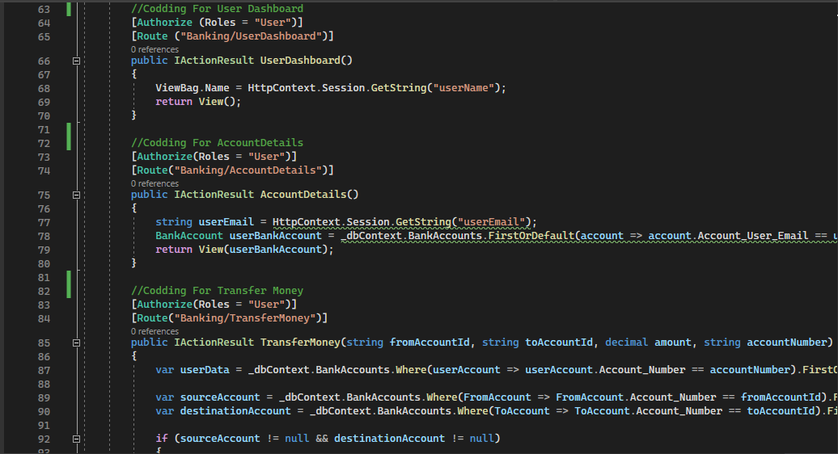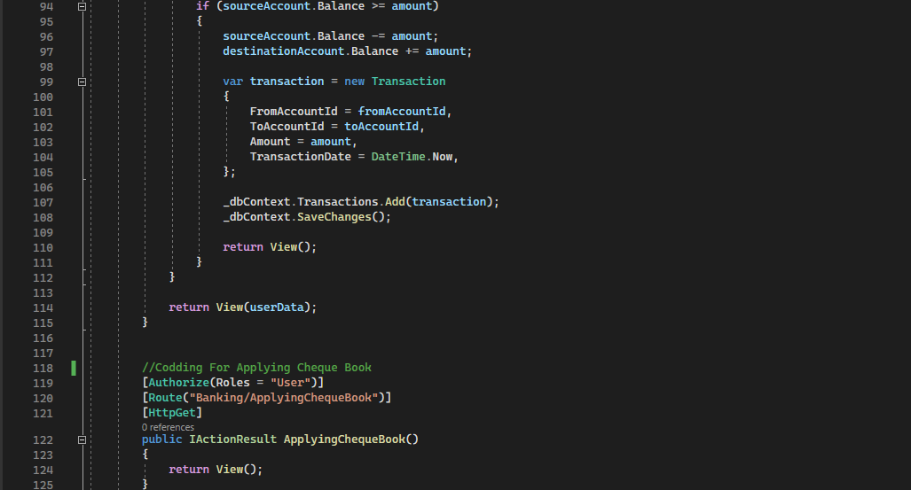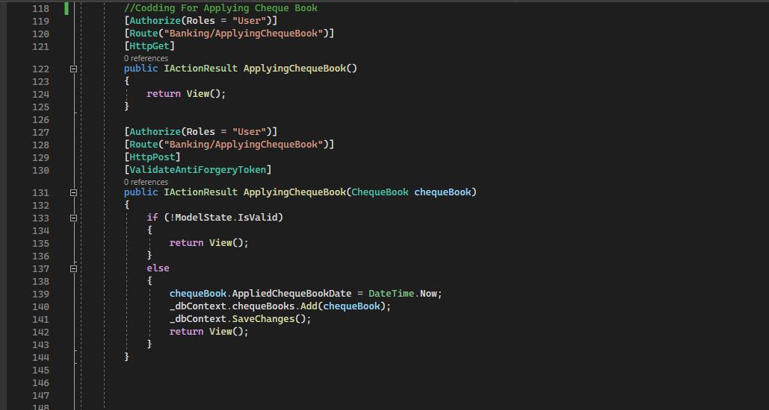

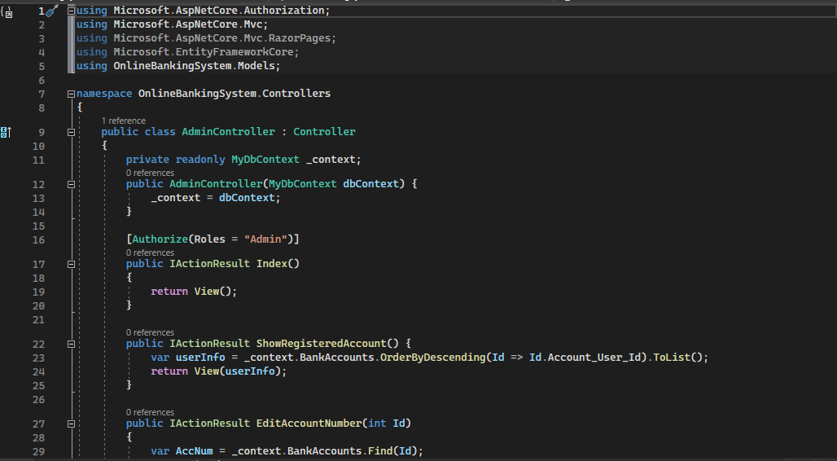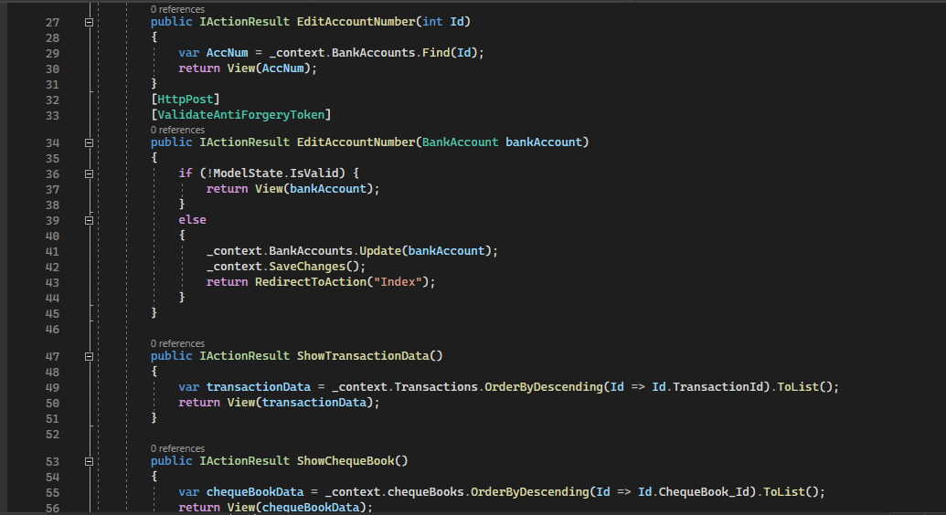

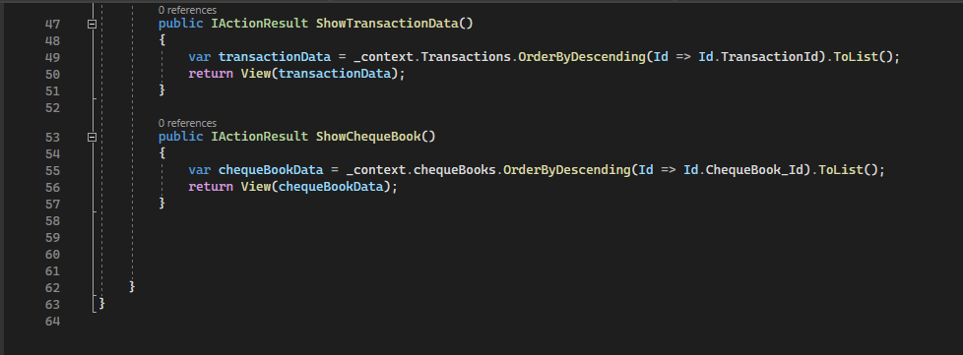

## Our Admin Panel

